Carbon Credits Keep Private Land Natural, Provides Incentives to Landowners
Posted by: Jay Barrett August 18, 2016
KMXT Public Radio, Kodiak Island

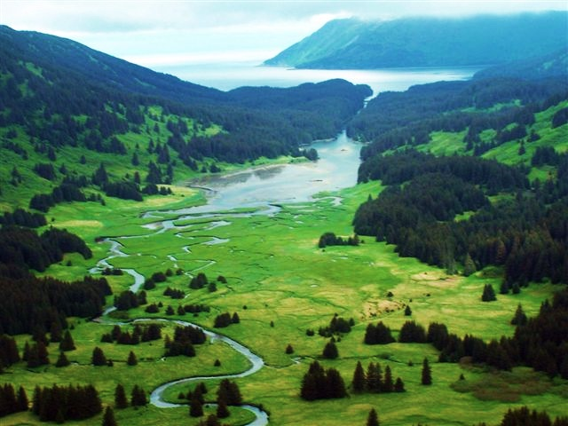

Trees have value that can be measured in many different ways. They have an intrinsic value for their beauty. Some are turned into log homes, others into lumber and a bunch into paper products. But by preserving a whole stand of them, the value of the trees can grow each year because of their place in nature’s carbon cycle.

As school kids are taught, trees absorb carbon dioxide and expel oxygen. And as long as that tree is growing, the carbon in the carbon dioxide it absorbed is stashed away, or “sequestered.” And corporations will pay good money to sequester part of the carbon from their environmental footprint.

And that’s happening on Afognak Island.

“The first forest carbon project in Alaska, occurred at Perenosa Bay,” said Tim Richardson, a conservation consultant with Wildlife Forever, who helped broker that deal. “It was conducted by the American Land Conservancy and the Rocky Mountain Elk Foundation when a purchase of Native Corporation land went to the state of Alaska through the Exxon Valdez Trustee Council. And the NGO, the conservation groups were in the chain of title in that transaction,” Richardson said.
“So we bought it, and then turned and sold in a back-to-back closing with the Alaska Department of Natural Resources using Exxon Valdez money.”

He said by being in the mix, the carbon credits could be extracted and put to use.

“And in that nanosecond that we owned the parcel, we claimed the carbon credit ownership – the interest in the carbon credits. Which at that time were purely hypothetical. None had been done in Alaska before,” Richardson said. “And the state and the federal agencies and the trustee council wanted to see if a new revenue stream could occur from the trees absorbing carbon dioxide from the atmosphere and storing it. And as they grew, they would continue to build more crediting that could be measured and turned into carbon credits and sold to people on the voluntary carbon market.”

The value of different forest carbon sinks vary, and the price paid for the credits is based on a negotiation with the client, but Dick Kempka, chief commercial officer with Climate Trust in Portland, Oregon, has some good guesstimates.

“But if you look at the voluntary carbon market average for last year, 2015, it was 3.3-dollars per ton. And if you look back at all the 155,000 acres of forest that were conserved in the EVOS on Afognak Island I calculated that it added $25-million to transactions that really cost $180(-million) for the Exxon Valdez to purchase. So it’s a bump,” he said.

Kempka said companies purchase carbon credits voluntarily because they want to be climate neutral or reduce their emissions liability. But it’s not a one-off, feel-good donation. Contracts are for quite a few years.

“I’m up here in Alaska talking to Native corporations and other private land owners who have an interest in that market and I help education them on what that market entails. The have to make a long-term commitment to be in the program. It’s typically a hundred years,” Kempka said. “And the payments are almost like an annuity. You get them every year as the tree grows. So they measure you in the first year and you’re either above a baseline or below it. If you’re above it you get a bump of credits, and each year after that, you get the growth. So it’s like an annuity they can get a payment for.”

Kempka said this trip, besides to check in on the Perenosa Bay parcel, he is speaking with other land-holders, such as Native corporations, who might be interested in setting aside some land for forest carbon sinks as investments.

